# **Final Year Project: Multiplayer Online Game with AI - Progress Report**

## **Progress Chart**

|  |  |  |  |  |  |  |  |  |  |  |  |  |  |
| --- | --- | --- | --- | --- | --- | --- | --- | --- | --- | --- | --- | --- | --- |
| **Agenda\Week** | **1** | **2** | **3** | **4** | **5** | **6** | **7** | **8** | **9** | **10** | **11** | **12** | **13** |
| Determine project direction |  |  |  |  |  |  |  |  |  |  |  |  |  |
| Find out feasibility of Mahjong AI |  |  |  |  |  |  |  |  |  |  |  |  |  |
| Explore Unity |  |  |  |  |  |  |  |  |  |  |  |  |  |
| Study Machine Learning |  |  |  |  |  |  |  |  |  |  |  |  |  |
| Research on TensorFlow & Pytorch |  |  |  |  |  |  |  |  |  |  |  |  |  |
| Research and understand Machine Learning agents (ML-agents) in Unity |  |  |  |  |  |  |  |  |  |  |  |  |  |
| Try out demo game using ML-agent in Unity |  |  |  |  |  |  |  |  |  |  |  |  |  |
| Identify methods to train the AI (Tic Tac Toe) |  |  |  |  |  |  |  |  |  |  |  |  |  |
| Understanding the of various data types seen in examples |  |  |  |  |  |  |  |  |  |  |  |  |  |
| Implementing the logic required by the AI |  |  |  |  |  |  |  |  |  |  |  |  |  |
| Write and troubleshoot the script for the AI gameObject |  |  |  |  |  |  |  |  |  |  |  |  |  |
| Training and troubleshooting the AI script with existing .yaml trainer file. |  |  |  |  |  |  |  |  |  |  |  |  |  |
| Edit the Tic Tac Toe script for faster training and troubleshoot errors |  |  |  |  |  |  |  |  |  |  |  |  |  |
| Create documentation for Unity ML agents |  |  |  |  |  |  |  |  |  |  |  |  |  |
| Plan AI for Phase 2 of Project (More complex game) |  |  |  |  |  |  |  |  |  |  |  |  |  |
| Discussion regarding difficulties faced and the ideal game structure |  |  |  |  |  |  |  |  |  |  |  |  |  |
| Discussion regarding difficulties faced and the ideal game structure |  |  |  |  |  |  |  |  |  |  |  |  |  |

## **Tasks Completed**

|  |  |  |
| --- | --- | --- |
| **Date** | **Number of hours** | **Task Completed** |
| 25-OCT-20 | Ongoing | Edit the Tic Tac Toe script for faster training and troubleshoot errors  Running game in parallel to speed up training |
| 25-OCT-20 | Ongoing | Plan AI for Phase 2 of Project (More complex game)  Currently decided on GinRummy due to similarities with Mahjong |
| 25-OCT-20 | 2.5 Hours | Discussion regarding difficulties faced and the ideal game structure  Matching game logic with AI logic, game logic research and troubleshooting, such as grouping for melds and sorting methods |

## **Problems Faced**

1. Training is too slow
   1. Run game with 19 parallel instances
2. Performance is too varied after team_changed (Every 10k steps)

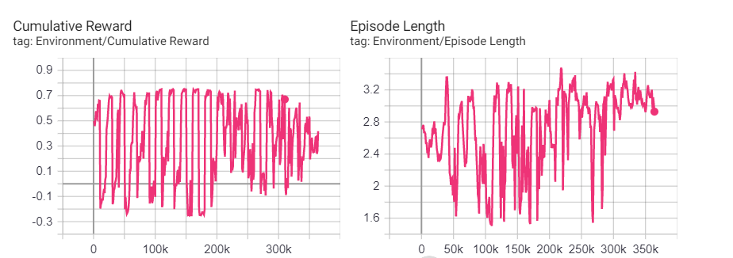

* 1. Reward Function if else statement missing an “else”, thus rewards are wrongly assigned for draw scenarios.
  2. Retried training with new code

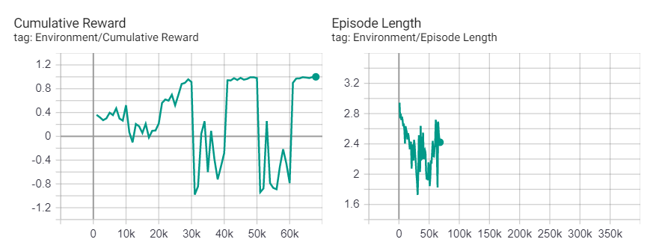

* 1. One team is training way better than the other, AI from team 1 is unable to learn due to a more superior opponent. Edit in the trainer script is required or reduction of parallel running scenes.
     1. Despite not optimal, AI realised that the corners or the center is important. The image below shows the first 2 steps taken by the AI. However the AI did not learn much after the first 2 steps

